Project Title: BalanceIQ
Date: April 30, 2025

1. Project Overview

BalanceIQ is a unified platform designed to help users monitor and enhance their physical, mental, and emotional well-being. By consolidating diet, exercise, and mental health tracking into a single intuitive interface, the application empowers individuals to take control of their health and maintain a balanced lifestyle.

2. Business Needs

Key Challenges Addressed
- Difficulty in capturing and correlating diverse wellness metrics in one place.
- Fragmented solutions for diet, fitness, and mental health tracking.
- Lack of clear, actionable insights into long-term health trends.

Business Benefits
- Increased user engagement through personalized dashboards and targeted recommendations.
- A scalable, high-performance platform capable of accommodating a growing user base and expanding data volumes.

3. Stakeholders
- Primary Users: Individuals seeking to track and improve their overall well-being.
- Administrators: Responsible for configuring the system, managing reference data, and generating reports on aggregated user metrics.
- Business Owners: Oversee strategic alignment of the platform with market needs and business objectives (planned for future releases).

4. Functional Requirements

4.1 Holistic Health Tracking
- Metric Recording: Allow users to log key health indicators (e.g., height, weight, blood pressure, heart rate).
- Trend Analysis: Provide interactive charts and graphs to visualize historical data and track progress over time.

4.2 Diet Management
- Meal Logging: Enable users to enter meals and snacks with portion details.
- Nutrition Insights: Integrate with the Nutritionix API to deliver real-time calorie counts and nutrient breakdowns.

4.3 Activity Management
- Activity Logging: Let users record workout sessions by selecting activity type and duration.
- Calorie Burn Estimates: Use external services (e.g., Nutritionix) to calculate calories burned based on logged activities.

4.4 Mental Health Management
- Mood & Stress Tracking: Allow users to record mood states, stress levels, and reflective journal entries.
- Relaxation Techniques: Offer tailored stress-management exercises and techniques via the GEMINI API.(Can be used in the future imprvements)

4.5 User Dashboards
- Personalized Dashboards: Present consolidated views of health metrics, dietary insights, exercise logs, and mental health entries in an interactive format.

4.6 Reporting & Administration
- Reference Data Management: Permit admins to define and maintain lists of health metrics, exercise types, and mood categories.

5. Non-Functional Requirements
- Performance: Ensure the system remains responsive under peak user loads.
- Scalability: Architect the solution to support future feature expansions and increased traffic.
- Security: Implement JWT-based authentication and follow best practices for data protection.
- Availability: Target 99.9% uptime to guarantee continuous access.
- User Experience: Design a responsive, accessible, and intuitive interface that works across devices.

6. Technical Requirements
- Backend: .NET Core with Entity Framework Core.
- Frontend: Angular framework enhanced with Toastr notifications.
- Database: Microsoft SQL Server.
- APIs: Nutritionix for dietary and exercise analytics; GEMINI for mental health recommendations.

7. Database Design

Key Tables:
- User: Stores user credentials and profile associations.
- Health Metrics: Defines available health metrics.
- Health Metric Log: Records individual metric entries per user.
- Activity Type: Lists admin-defined exercise categories.
- Activuty Log: Captures user workout details.
- Mood: Enumerates mood states tracked by the system.
- Mental Health Log: Logs mood entries and journal reflections.
- Diet: Records meal logs along with nutritional data retrieved from external APIs.

8. Block Diagram

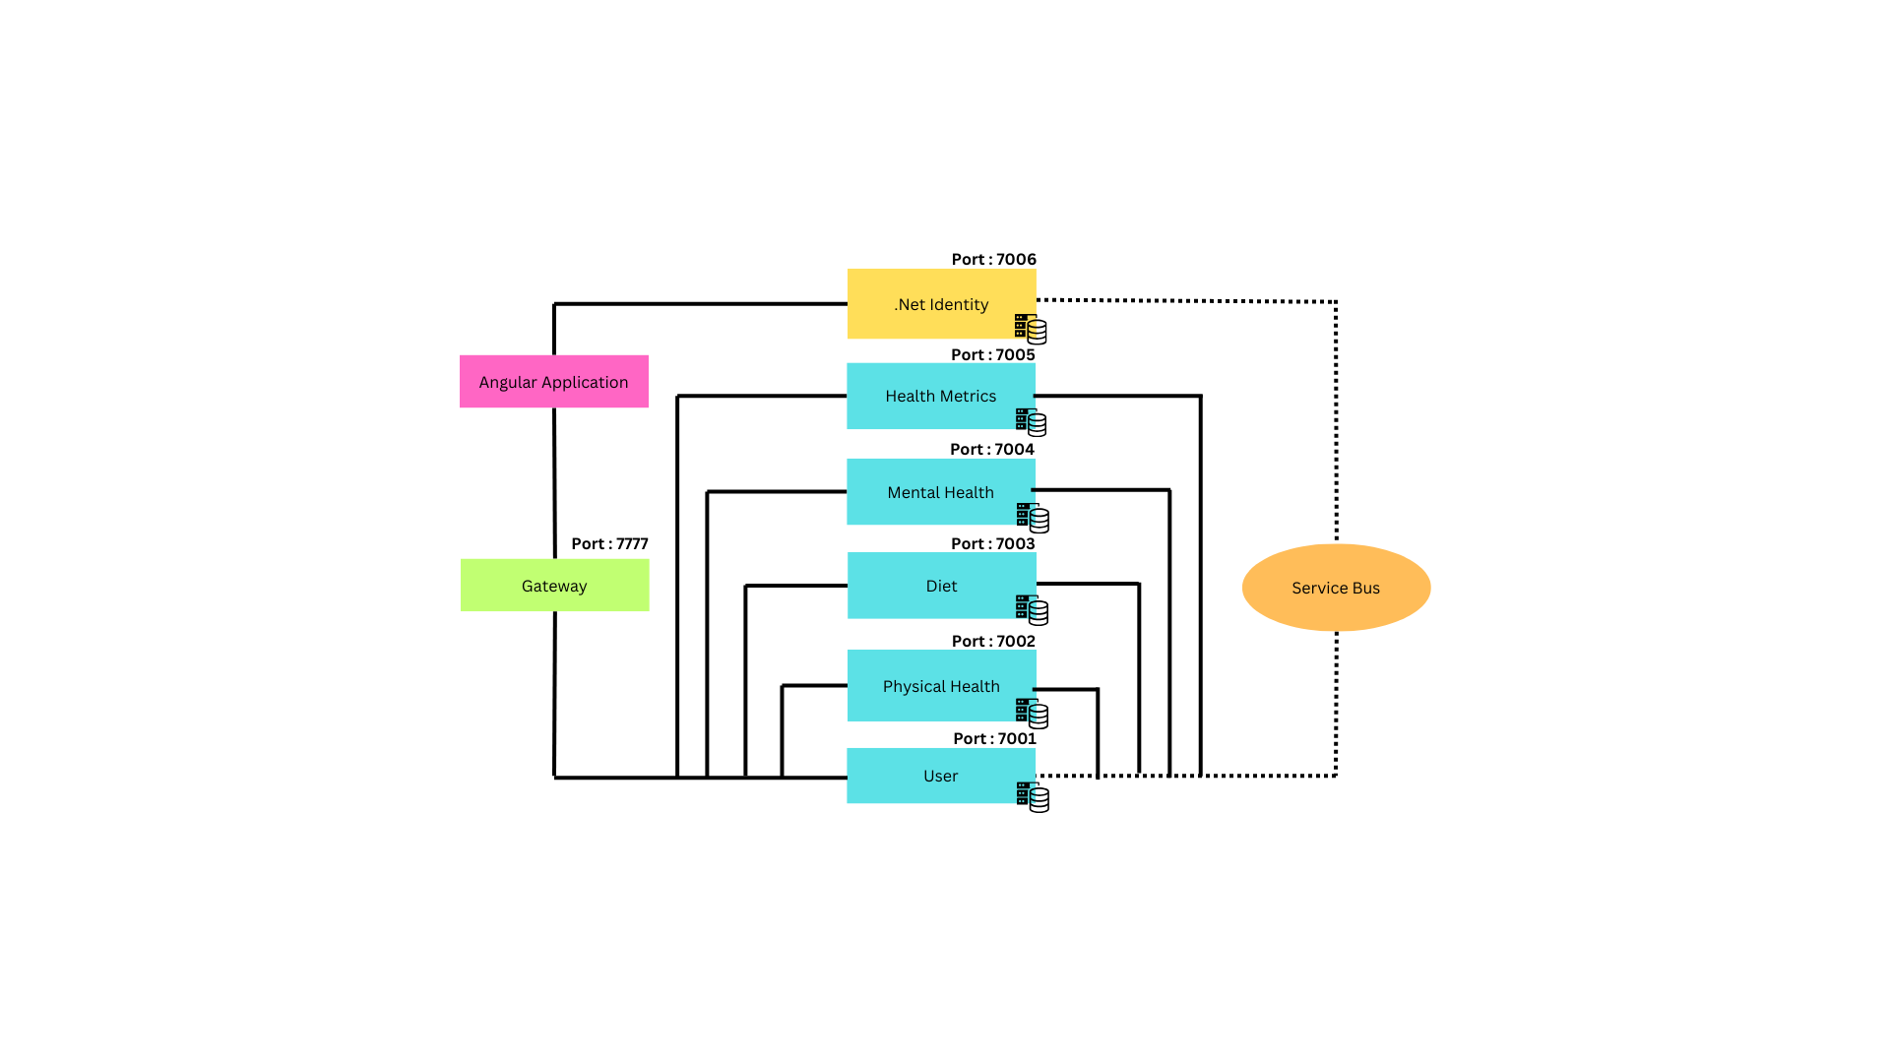

9. Flow Chart

